Exercise 5: MQTT Reliability, QoS Handshakes, and Retained Messages

Step 1: Role Reversal - Configuring Node-RED as the Subscriber
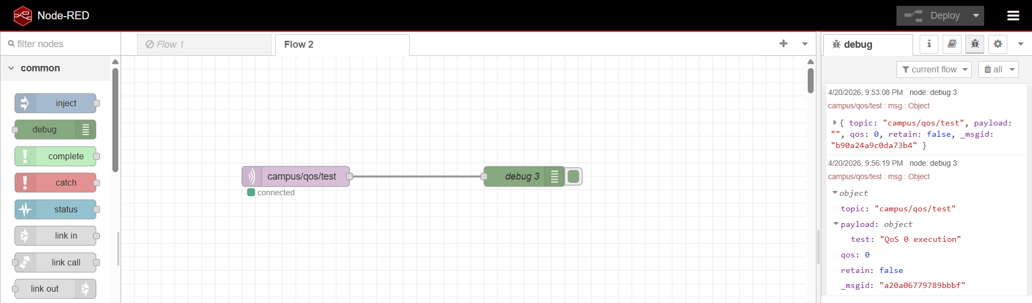

Step 2: Wireshark Initialization & QoS 0 (Fire and Forget)

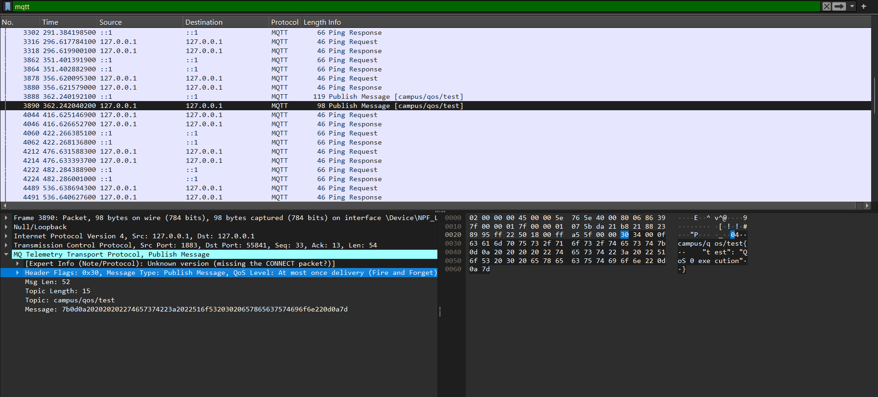

Step 3: Verifying QoS 1 (At Least Once) and QoS 2 (Exactly Once)
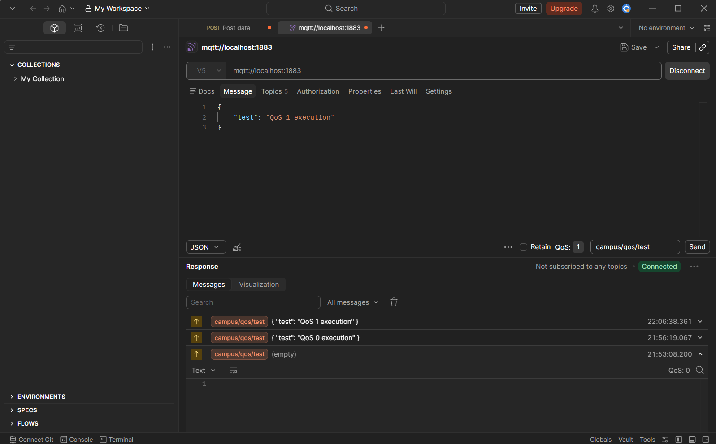

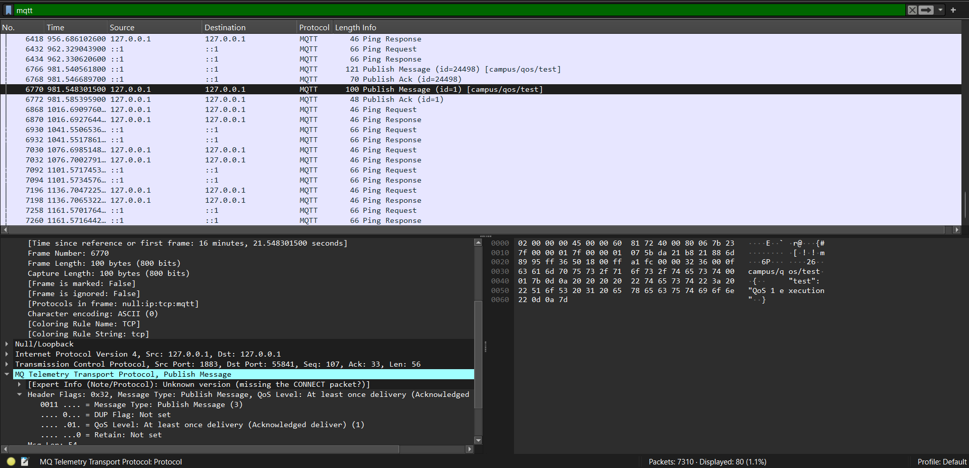

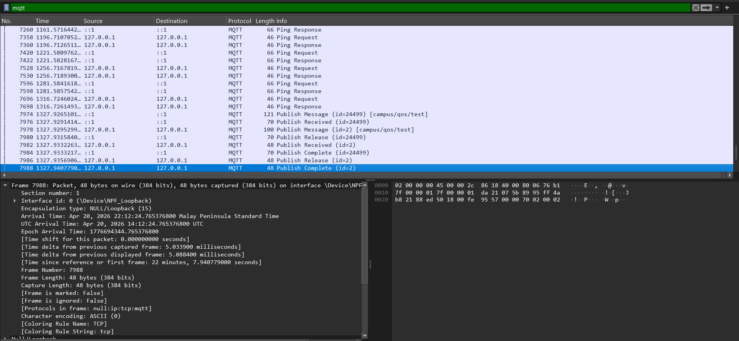

Step 4: The Retain Flag Mechanism
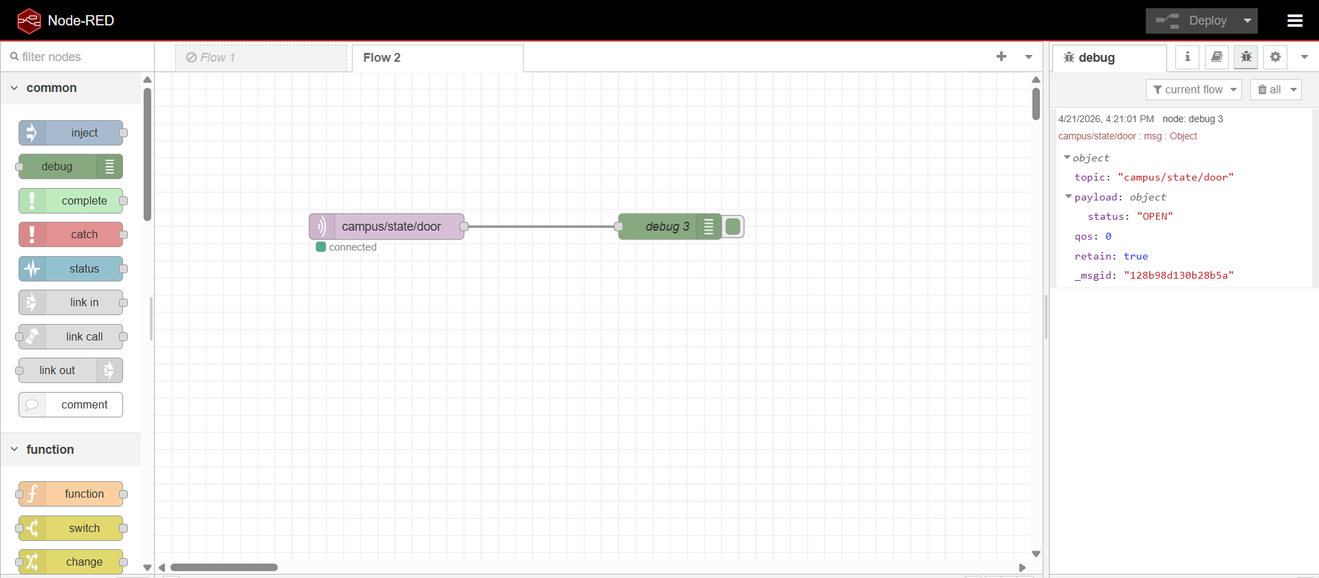

Part 5: Discussion & Architectural Analysis

Question 1 Choose QoS 0 for battery-powered ESP32 sensor (updates every 10s): Minimizes packets (1 vs 2/4), saving battery/bandwidth; reliability less critical for frequent non-vital data. QoS 2 misuse: 4x packets vs QoS 0 quadruples radio-on time, draining battery 4x faster; bandwidth 4x higher.
Question 2
Standard MQTT: Delivers once if subscriber online; Retained: Broker stores last message, delivers on new subscription (e.g., IIoT safety: Door sensor retain "OPEN" ensures new dashboard sees state instantly, preventing unsafe assumptions).

QoS Breakdown
- QoS 0: No ACK; fastest, lowest reliability—ideal for frequent non-critical data.
- QoS 1: Publisher gets PUBACK; delivery assured but duplicates possible.
- QoS 2: Full handshake (PUBREC/PUBREL/PUBCOMP); highest reliability, highest overhead.

